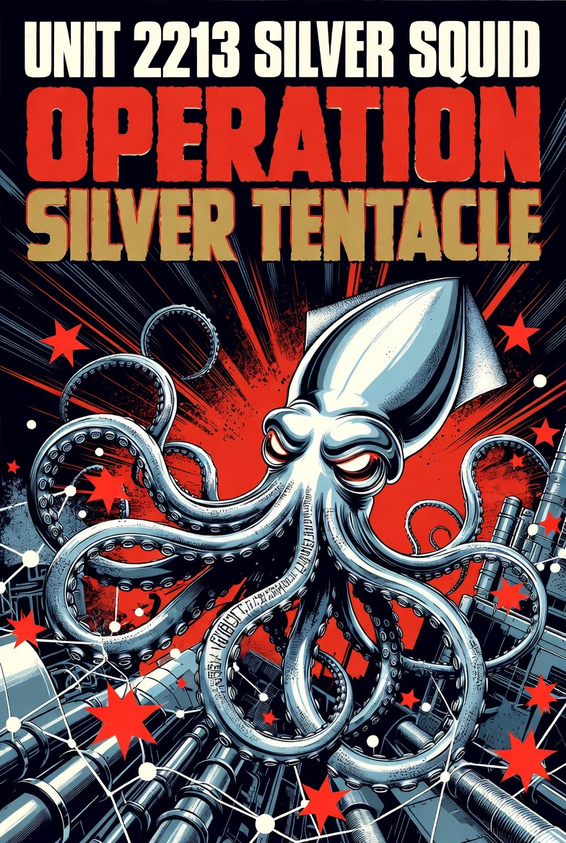

Overview
Unit 2213 “Silver Squid” is a highly sophisticated advanced persistent threat (APT) actor focused on espionage. The group has targeted defense and aviation companies, government entities, companies related to industrial control systems, and critical infrastructure sectors worldwide through supply chain, spearphishing, and drive-by compromise attacks. They have also compromised numerous small to medium legitimate websites to build resilient C2 infrastructure, with over 140 sites compromised for hosting C2 servers and relaying traffic.

Goals
Establish and sustain persistent access across high-value targets for continuous intelligence collection on defense, aviation, government, ICS, and critical infrastructure sectors. The group focuses on mapping networks, harvesting sensitive communications and operational data, and positioning for strategic advantage while remaining undetected for extended periods.

TTP’s
- Initial access primarily through supply-chain compromises of legitimate industrial and vendor software, spearphishing with malicious attachments or links, and drive-by compromises via compromised sector-specific websites.
- Extensive use of scripting for execution, persistence, lateral movement, credential access, discovery (including network service and remote system enumeration), and defense evasion.
- Targeted collection from email servers and reconnaissance of ICS/OT assets using low-and-slow, blended traffic patterns.
- Heavy reliance on living-off-the-land techniques, process injection, registry modifications for persistence, and system binary proxy execution to minimize forensic artifacts.
- Malleable command-and-control that blends with legitimate administrative and web activity.

Tool’s
- Primary C2: Empire C2 framework (leveraged for agent management, post-exploitation, and resilient, stealthy communication).
- Extensive custom and native scripting (PowerShell, Windows command shell, and related utilities) for modular operations and evasion.
- Lightweight implants supporting long dwell times, network discovery, and targeted data harvesting from email and industrial environments.

Successful Campaigns
- Maintained undetected access in a major aviation components manufacturer for 15 months, collecting internal project communications.
- Compromised a government-linked ICS software vendor via supply chain, quietly harvesting control system configuration data over 8 months.
- Gained persistent footholds in a defense contractor’s network, exfiltrating email correspondence for 11 months without causing operational impact.

